Background to the event
In December 2023, the Minister for Higher Education and Further Education, Graeme Day, announced that a review of Community Learning & Development in Scotland would be undertaken from December 2023 to June 2024. The purpose of the Review was to understand CLD’s outcomes from Scotland’s most vulnerable and marginalised groups, in a wider context of education reform and stretched public finances. The review proposed to examine CLD’s contribution to Scottish Government priorities and sought recommendations on ‘the improved life chances for marginalised and vulnerable learners, in the context of wider education reform and public finance constraints’ and on ‘a strong and suitably equipped workforce’(Scottish Government, 2023). The review was framed specifically around education for employability, stating that, 'The cross-cutting nature of CLD provision means that there is a likelihood of the community development/empowerment element of CLD being raised by stakeholders in the course of the review. Nevertheless, the focus will remain on the educational elements.’
While CLD practitioners and academics welcomed the policy attention to CLD, many raised concerns that the terms of reference ignored the transformative social purpose at the heart of the profession and neglected essential aspects of CLD’s three domains of youth work, adult education and community development. The community argued that the learning and development components of CLD could not be separated without losing the ethos and values of the profession in relation to social justice. This concern was considered particularly acute in the wider context of more than a decade of austerity, a global pandemic and cost of living crisis that have further entrenched deep inequalities across Scottish society. A million people remain in poverty – a quarter of these children and young people - with half a million experiencing ‘deep poverty’ (Rowntree, 2023³), whilst health inequality continues to grow (Health Foundation, 2023⁴).
In February 2024, CLD academics voiced these concerns in a letter to the Minister, including a proposal for greater collaboration between the Review and the CLD community of academics, voluntary and public sector practitioners. This was followed up by the Scottish Government’s Directorate of Lifelong Learning, who consulted in depth with members of the group on the literature review which accompanied the report from independent reviewer Kate Still.
As a follow-up, the group hosted an event at the University of Edinburgh to explore the current state of the field and to surface our own CLD practice, policy and research recommendations for the field. Participants were invited to consider where best to focus our energies and resources to best service the people and communities with whom we work.

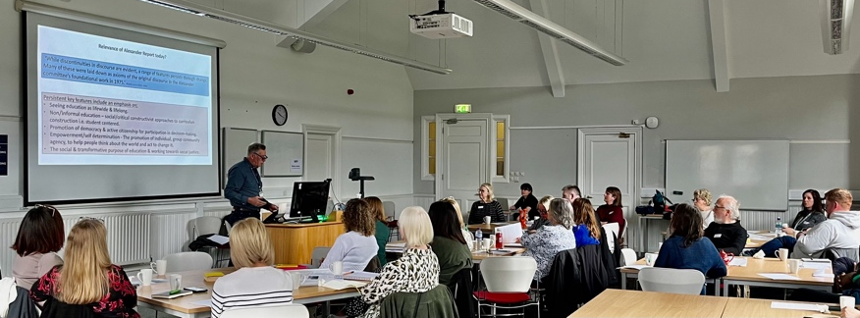
The State of The Field - Seminar and Workshop
An invitation was sent to CLD practitioners and academics across the sector, drawing on a range of public practice and academic networks. The event took place on 14th June 2024 and was planned and facilitated by academics from the Universities of Edinburgh, Dundee and Stirling. The event was attended by 37 participants: 13 from public sector, 10 from voluntary sector and 14 academics involved in teaching and/or research in Community Learning and Development.
The programme included reflections on the Alexander Report (50 years on) from Dr. Stuart Moir and a keynote from Professor Sinead Gormally on the future of CLD in Scotland. Gavin Thomson from growing2gether in Forres shared collaborative and empowering work with young people in the community.
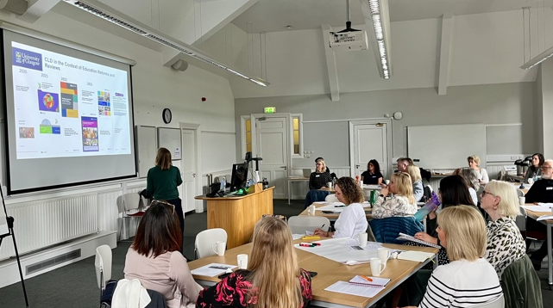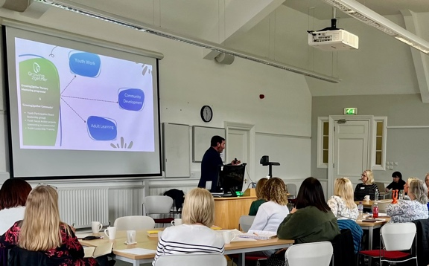
The group was then invited to participate in roundtable discussions, to consider three key questions:
- What are the current priorities for CLD practice in Scotland?
- What are the current priorities for CLD research and training in Scotland?
- What are your top three priorities for future action in CLD?
Group responses to the three questions demonstrated common thinking across some key themes for CLD.
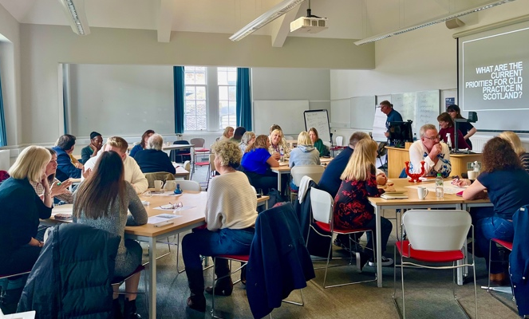
Q.1: Current priorities for CLD practice in Scotland
In response to current priorities, groups highlighted the importance of sector identity, workforce development, addressing the funding crisis and demonstrating impact.
A clear and united identity for the sector across the three domains of youth work, adult education and community development was raised repeatedly across groups. This was considered an imperative in the current climate and would help protect the sector from further cuts by presenting a united profession with shared core values and skills.
A focus on the workforce should enable the articulation of clear career pathways of progression. Offering ongoing professional training, rooted in research and practice excellence, would help support worker integrity and development, and should be linked to registration with CLD Standards Council.
Many highlighted the funding crisis for the sector, and the wider impacts of cost of living crisis on society, which had necessarily pushed CLD towards welfare provision, to meet the needs of society’s most disadvantaged. Groups discussed the scope for partnerships to offer wraparound services in the community, the need to pivot to align with current policy priorities such as Learning for Sustainability, the wellbeing economy and ESOL, and the promotion of creative alliances with allies.
A need for the effective demonstration of impact was needed to support effective communication on the difference that CLD makes to Scotland’s marginalised communities.
Q. 2: Current priorities for CLD research and training in Scotland
Several areas for research were prioritised. The need for longitudinal research to capture CLD’s impact over time was raised by groups across all three of the questions. Evaluating the effects of specific policy initiatives such as community asset building would ensure that the appropriate strategies were undertaken to meet the long-term goals that communities want and need. Alongside these themes, research on the sector itself and the workforce was considered important. Mapping CLD practice across domains would help the sector to organise strategically, and grounding research in practice would ensure that findings were meaningful and relevant. Research on current societal challenges would help to inform good practice and prepare staff for future uncertainties and challenges.
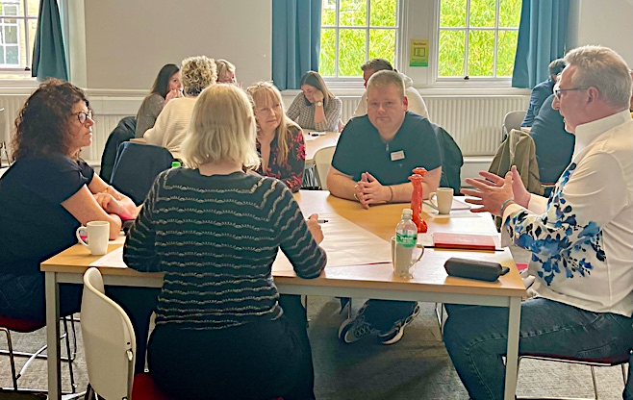
Q. 3: Top 3 priorities for action
There was a strong correlation amongst groups on their top 3 areas for action.
The collective identity of the sector was raised by all groups, most citing this as their first objective. In all cases, participants considered that the sector needed to construct a clear narrative on the value and evidence of its work for the public; the celebration of existing success would help to support this.
Several groups highlighted the need for clarity of career pathways across all levels of the profession. Consistent naming of roles, parity of pay and consistency of skills were considered to be key to building clear progression routes and improving professional regard and parity with other sectors.
Demonstrating and sharing impact of the valuable work that goes on daily in communities was also considered foundational to the success of the sector.
Event evaluation
Feedback from the event was very positive. 100% of participants scored the event either ‘very good’ (43%) or ‘excellent’ (57%). Participants valued the keynote and presentations from practice and academic staff, but most of all benefitted from the opportunity to reflect and discuss current key issues with colleagues from across the sector.
Participants would have liked to have more time at the event, and would welcome more inputs, especially from practitioners working in the field. Others reflected that the events could have represented a more diverse range of voices and could have had greater representation from CLD leadership and from ‘non-qualified’ CLD practitioners.
Event feedback suggested that thematic working groups/communities of practice on the critical issues would be valuable. Many participants were willing to contribute their expertise to these groups in different ways.
Alignment with CLD Review
In July 2024, the CLD Review, ‘Learning: For All, For Life.’ was published. Despite the limitations of the terms of reference on education for employability, the report reflected that 'CLD is the invisible glue that holds many of our communities together' (p.33), highlighting the sector's unique contribution to wellbeing in disadvantaged communities. Evidence on outcomes included personal and social capabilities (improved sense of identity and self-worth; increased civic engagement and participation); health and wellbeing (improved health literacy; support for sexual health and substance use; extensive physical and mental health benefits); and education and employment capabilities (enabling people to develop the skills they need for life and work, such as literacy, numeracy, digital skills and ESOL; providing an alternative means to learn basic skills for young people who face barriers to engaging with school).
The Review made recommendations under six themes: leadership and structures, policy narrative, delivery, budgets, workforce and impacts. Many of these resonate with the priorities for action highlighted during the State of the Field event. In October 2024, Independent Reviewer delivered the annual CLD Members lecture at the University of Glasgow. She urged members to take action based on the recommendations of the Review, stating that the coming weeks offer a brief window of opportunity within which the Review has policy currency. CLD Members should come together to prioritise recommendations, rather than leaving this to be framed by the Scottish Government response.
We therefore take this opportunity to share our collaboration to date, and plan for next steps for action over the period to December 2024. We invite contributors to the State of The Field event and other interested parties to propose leadership and/or contribution to the key recommendations and priorities for CLD’s future.
Next steps
Identify working groups to lead/contribute to recommendations from the event and the CLD Review. Groups may include, but are not limited to, the following themes:
- Building a coherent identity/shaping the policy narrative
- Developing the Workforce
- Demonstrating Impact
We propose to explore three collaborative communities of practice which focus on these issues and develop briefing papers for presentation to CLD members and Scottish Government by end of November 2024. We invite participants to express interest on key themes by end of October 2024, with the aim of creating working groups to lead on these areas of development.
Additional themes which have been raised by the Review recommendations include Leadership and structures, Budgets and Funding, and Delivery. These will also be areas of interest and potential contribution to some. We suggest that CLD Standards Council may wish to convene communities of practice to take forward action on these themes.
Many thanks for your participation in the State of the Field Event.
Event Facilitators
Sarah Galloway, University of Stirling
Sarah McEwan, University of Dundee
Sarah Ward, University of Edinburgh
Stuart Moir, University of Edinburgh

APPENDIX 1 – GROUP FEEDBACK ON QUESTIONS
Q1: WHAT ARE THE CURRENT PRIORITIES FOR CLD PRACTICE IN SCOTLAND?
GROUP 1
- Learning for Sustainability
- Professional integrity (retraining)
- Identity, e.g. job titles
- How can workforce meet the needs of community?
- Identity for Adult Education as part of CLD and third sector part of the CLD
- Space and profile of CLD students in HE
- Will review impact CLD registrations? – and strengthen them
- Are pathways to the sector available and effective – HNC Working in Communities
- Apprenticeships?
- Mandatory registration
- Community awareness / engagement -people talking about what we do!!!
GROUP 2
Current, hot topics, priorities for CLD practice in Scotland:
- Squeezed by funding and politics
- Becoming a welfare agency – providing food and clothes
- Building capacity of the charity, including organisations not necessarily sharing the values of CLD – reinforcing dependency and preserving their position
- Funding crunch. Crisis funding e.g. lottery funding, prioritising wrap around. Language of ‘support’ not CLD.
- A state of poly/perma crisis
- We are in a nara-digm – of centralising power – private interests and property
- Loss of any ‘foundation of truth’, post truth environment, very hard to discuss questions of democracy
- Lack of consensus to begin a conversation
- The ‘Emperor’s new clothes’ - hiding from communities the reality of cuts, loss of services from management – denial / avoidance.
GROUP 3
IDENTITY
- As a sector we need to be willing to accept change
- Parity of esteem – connected to job titles
- Not all qualified CLD workers – but experienced and working in field
- Would you be a SW / teacher without a SW/teaching qualification?
- Broader than just CLD qualification, practice ‘vs’ degree?

PATHWAYS
- Is needing a degree a barrier
- Mandatory reg of CLDSC – different levels of membership
- Knock to self-confidence – not good enough to be a reg. member
- Pay ↓ no incentive to go into a CLD career

FINANCIAL SITUATION
- Particularly LA - don't know where we'll be in 12 months
- not a statutory service so goes
- statutory obligation on LA - can be anyone delivering
- LA service an easy hit - know vol sector will pick it up?
- Employability isn’t our game!
- job consistency - zero hour contracts
- job consistency - impact on planning and practice
- less £ / resource / stuff - impossible in the field to do the challenging – needs to happen at the top
- disparity within the field e.g. £ AL / YW and inconsistency across LAs, sitting in different places.

DATA/IMPACT
- Need to clearly demonstrate what we do

IDENTIFY OUR ALLIES
GROUP 4
IDENTITY OF CLD
- Articulate that we are a profession
- External view that anyone can do CLD
- Day-to-day work takes priority
- Disconnection of ‘coal-face’ workers from wider conversations
- More people doing CLD but not qualified
- Need to be protectors of CLD
- Where are our champions?
- Local Authorities don’t have understanding of CLD
- Tiring constantly advocating for what we do and who we are
- Need to clearly define our practice
- Challenge deficit view of our practice (eg we work with ‘bad people’ - not true -need to agitate
GROUP 5
CLD PRACTICE – definition – what is it??
LANGUAGE
- Clarity is v important
- Eg participatory budgeting
- SCDC doing new weekly newsletter
- Training requests for basics

QUALIFICATIONS
- “Essential but not sufficient?”
- Needed experience, skills and qualities for interview. People skills crucial.
- Line management – teams often not managed by qualified/experienced staff
- Tensions in academic vs vocational in universities

PARITY OF THE PROFESSION
- Still sometimes seen as ‘poor relation’. Need to change the narrative.
- Recognising skills and professional practice of Community Development. Eg technology students going to community festival

IDENTITY OF CLD
- Combination of practice & theory
- We all have responsibility for supporting connections and learning from practice & theory
- Professional identity is important!

Q 2: WHAT ARE THE CURRENT PRIORITIES FOR CLD RESEARCH AND TRAINING IN SCOTLAND?

GROUP 1
- Funded student placements
- Graduate apprenticeships
- Time limited BA and funded – mandatory registration
- Mapping of CLD and 3 domains in Scotland
- Cohesive policy context → and resources teams and where if sits
- Data and informing priorities – one system?
- Non tokenistic engagement
- Disengagement with political process – CLD – engage communities and individuals
- Training for elected officials and managers – CLD
- What funding is in the system being tagged as ‘CLD’ → economic literacy
- LONGITUDINAL RESEARCH OF BENEFITS
- → CLD workforce and communities and learners
- → Pivot to play ‘the game’
- → NEED TO LINK TO POLICY: Wellbeing economy, LFS, ESOL

GROUP 2
Gaps in knowledge and skills in CLD
- Lack of knowledge of environment / climate in CLD workers
- How prepared are our communities for the next unknown?
- Overcoming the cognitive dissonance to asking – How can we?
- How do we develop and safeguard critical thinking in this day and age?
- How do we address the gap between the narrative and the realities of community empowerment?
- What are the ethics of communities managing and owning assets? – the weight of responsibility, confusion between ownership and empowerment)
- How to address the bottleneck from engaging communities to influencing power holders?
GROUP 3
- LONGITUDINAL RESEARCH
- Network of where we are and what people do
- Sectoral analysis … but difficult to do – those with no quals don’t know they’re doing CLD
- Term – ‘CLD approach’ - 2 different things: Also about long term impact on the people we work with
PEOPLE NEED TO BE MORE CRITICALLY ENGAGED – SHARE THE RESEARCH - time restraint

PATHWAYS
- Consistency across FE/HE – if people are searching for causes
- Idea that HE isn’t for certain people but not true
- Needs to be a priority for CPD for all practitioners.

PROTECTED TIME FOR CPD
- Upskilling practitioners around sharing and linking up good practice (simpler than HE/FE research)
- What message are we trying to say and how do we say it and who to?

ONE PLACE FOR INFORMATION
- Open to everyone
- Non – intimidating
- Connect different practices
- Utilise Concept Journal?
- Could be research and sharing of practice

WHAT IS NEXT?! ((We are a profession NOT an emerging profession))
GROUP 4
GAP IN RESEARCH ON OUR WORKFORCE – aging, diversity, unclear titles, health, female dominated
GAP IN IMPACT OF CLD
- Longitudinal studies to demonstrate impact
- Need to disseminate research that is being done by students
- Practice research impacting service delivery
- V difficult to evidence prevention
- Measurement all v different
- Reframing information
- NO TIME FOR RESEARCH IN PRACTICE – HOW CAN THIS BE AMENDED?
- Know what’s being done by Unis, FE etc
TRAINING STRATEGIC LEADERS
GROUP 5
UTILISE PRACTICE-BASED RESEARCH METHODS
- From design of research onwards (i.e. embed practice from start)
- Action Research (participatory, truly community-led)
- This puts our values into practice?
- Grounded theory approach
- Co-design and designing for the future

ENGAGE STUDENTS IN RESEARCH AND PARTNERSHIP/COMMUNITY ACTION RESEARCH PROJECTS
- E.g. Health inequalities in the community (CHEX)
- Short courses for health issues in communities
- Promotion of genuine approaches

RESEARCH AROUND HOW TO MAINTAIN & UPHOLD CLD VALUES IN
STRUCTURED SETTINGS
- E.g. Employability

EXPLORE HOW TO CAPTURE LONGITUDINAL IMPACT ‘LONG-TERM’
- E.g. Impact of young carers group 10 years on
- Impact of ‘early intervention’
- Celebrating young volunteers – big impact but need to capture and hold on to key elements of the journey/impact/skills development
- Is this starting the training for the next generation of youth workers?
- Start early with clear progressions – PDAs, HNC, Widening Access etc.

Q 3: WHAT ARE THE TOP 3 AREAS FOR ACTION, and what resources are required?
GROUP 1
- Resources – who what when + 3 key
- Joined up thinking on funding
- No core funding to support staff for delivery, i.e. NOLB, MULTIPLY etc.
- Multi-year funding
- ‘Minimum’ resource targets??
- Make us ‘statutory’
- Needs led funding – ‘failure spend’
- Trained, resourced, competent practitioners
- Identity
- Celebrate

- COLLECTIVE APPROACH
– 3 domains
– research
- CHALLENGE NARRATIVE
- CELEBRATE CLD AND DOMAINS. Who we are.

GROUP 2
Resources required – who, what, when?
- Community led evaluation – tracing the deliberative process through to impact
- The identity problem ….’of the profession’ → routes to qualification, affordable for small charities
- What do communities need for the next unknown?
- We need a public information programme
- The importance of standards / values
- The issue of dilution of the profession and the recognition of the need for qualified staff
- Disconnect between people who need CLD and recognition of the profession

GROUP 3
RESOURCES REQUIRED – YES

- PATHWAYS
- so different
- a million different pathways into profession
- Future-orientated

- A FIELDWIDE DISCUSSION (not just 40 people)
- forget about the review, this needs to happen anyway (+ needs to be wider)
- are the 3 domains still relevant?
- 3 domains equal = IDENTITY!
+
connected but specific…….
- Acknowledge specialisms

- CELEBRATE WHAT WE ARE!
- not necessarily about parity
- why we are unique

FOCUS ON → ***Values and principles*** Getting hung up on language? Need a common one.
GROUP 4
- CONSENSUS ON TITLE
- If CLD works fine then let’s get behind it and use it

- IMPACT
- What and how do we measure
- Training methods
- Core systems
- Social return on investment

- IDENTITY
- Understanding workforce
- Community of practice
- Progression routes
GROUP 5
- NAME IT! (ie the Profession)

- USE CREATIVE METHODS TO RAISE AWARENESS OF THE PROFESSION AND ITS IMPACT
- Be clear on the purpose – social change
- Profile and visibility

- RESOURCE QUALITY PRACTICE PLACEMENTS TO SUPPORT STRONG DEVELOPMENT AND RANGE OF OPPORTUNITIES FOR STUDENTS
- Links to accessible pathways
- Properly resourced and funded courses
- Ie. Parity with other professions

