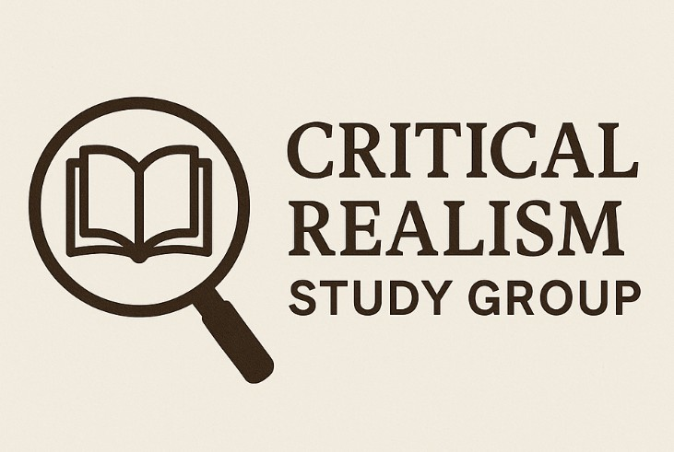

**Critical Realism Study Group**

**Moray House School of Education, University of Edinburgh**

[**https://education-sport.ed.ac.uk/research/centres-groups-networks/critical-realism-study-group**](https://education-sport.ed.ac.uk/research/centres-groups-networks/critical-realism-study-group)

**Resources**

**Applying a conceptual framework:**

*CR and CCPEE (Critical cultural political economy of education)*

Lopes Cardozo, M. T. A., & Shah, R. (2016). A conceptual framework to analyse the multiscalar politics of education for sustainable peacebuilding. *Comparative Education*, 52(4), 516–537.

<https://doi.org/10.1080/03050068.2016.1220144>

*CR and feminist approaches* (note the large section on ethics and reflexivity, coherent with a feminist framework)

Parr, S. (2015). Integrating critical realist and feminist methodologies: Ethical and analytical dilemmas. *International Journal of Social Research Methodology*, 18(2), 193–207. <https://doi.org/10.1080/13645579.2013.868572>

**CR and methodologies:**

*CR case studies*

Easton, G. (2010). Critical realism in case study research. *Industrial Marketing Management*, 39(1), 118–128. <https://doi.org/10.1016/j.indmarman.2008.06.004>

*CR and the analysis of structure and agency:*

Stutchbury, K. (2022). Critical realism: An explanatory framework for small-scale qualitative studies or an ‘unhelpful edifice’? *International Journal of Research & Method in Education,* 45(2), 113–128. <https://doi.org/10.1080/1743727X.2021.1966623>

**Applying data analysis methods:**

*CR Interviews:*

Brönnimann, A. (2022). How to phrase critical realist interview questions in applied social science research. *Journal of Critical Realism*, 21(1), 1–24. <https://doi.org/10.1080/14767430.2021.1966719>

*CR and grounded theory*

Hoddy, E. T. (2018). Critical realism in empirical research: employing techniques from grounded theory methodology. *International Journal of Social Research Methodology*, *22*(1), 111–124. <https://doi.org/10.1080/13645579.2018.1503400>

*CR and (deductive) data coding:*

Fletcher, A. J. (2017). Applying critical realism in qualitative research: Methodology meets method. *International Journal of Social Research Methodology*, 20(2), 181–194. <https://doi.org/10.1080/13645579.2016.1144401>

*CR and CDA:*

Couch, D. (2022). Critical realism and education policy analysis in conflicts and crises: Towards conceptual methodologies. *Compare: A Journal of Comparative and International Education*, *52*(6), 998–1014. <https://doi.org/10.1080/03057925.2020.1848519>

Huang, P., & Pu, S. (2024). Towards an explanatory critique of social reality: how critical realism can frame the application of critical discourse analysis in educational research. *Cambridge Journal of Education*, 54(2), 183–198.

<https://doi.org/10.1080/0305764X.2024.2335165>

Thematic Analysis:

Fryer, T. (2022). A critical realist approach to thematic analysis: producing causal explanations. *Journal of Critical Realism*, *21*(4), 365–384. <https://doi.org/10.1080/14767430.2022.2076776>

**Institutes and Centres *(for additional resources)***

Critical Realism Network: <https://criticalrealismnetwork.org/ccr/>

International Association for Critical Realism: <https://www.criticalrealism.org/>

The Centre for Social Ontology: <https://socialontology.org/>

Cambridge Social Ontology: <https://www.csog.econ.cam.ac.uk/>

University of Aberdeen’s NIHR project: CR Terminology <https://www.abdn.ac.uk/education/research/networks/projects/cgd/our-research/health-and-wellbeing/nihr-group/about-the-project/critical-realism/>