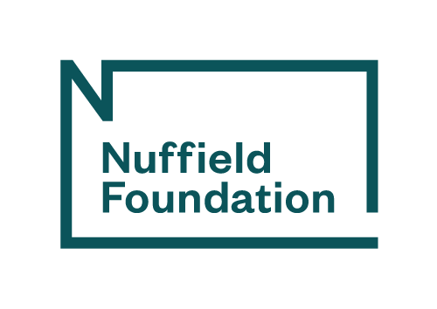

Embargoed until 00.01am on Wednesday 6 August 2025

Press release: new study finds sharing policy successes within the UK offers solutions for early years workforce
Early Education has released an interim report of its comparative study of early years workforce policies across the four UK nations. It finds common challenges but also examples of successful actions within each nation that could inform policy elsewhere within the UK.
The report, funded by the Nuffield Foundation, identifies a series of common issues and challenges around quality, equity and sustainability, and a need for strategic responses to these. Principal Investigator, Professor Dame Cathy Nutbrown, said:
“Our four nations have many issues in common, and there is a need to learn more from each other. A picture is emerging of a workforce united in its commitment to providing quality group setting experiences of education and care for young children but fractured and burdened by some policies which have allowed division by siloed systems and a patchwork of initiatives which need greater cohesion. We look forward to thinking further on this in our final report.”
Shared challenges identified include:
- concerns about qualification requirements for educators and the quality of learning and development opportunities
- the need for more graduates and teachers to provide pedagogical leadership
- better opportunities for career progression
- low pay and status within the workforce, linked to issues of funding and sustainability within the sector
- sectoral fragmentation, especially between the state sector (schools) and other early years settings
- a lack of diversity, both in relation to the low percentage of men in the profession and lack of data on the representation of different ethnic groups.
- a lack of workforce representation and voice
- widespread perceptions of a recruitment and retention crisis.
The unique nature of each UK nation was noted, including the particular challenges of increasing the pool of Welsh-speaking educators in Wales, and the impact of more than a decade without a devolved government in Northern Ireland to enact early years policy. Scotland and England have both, in different ways, faced challenges due to governments extending their funded early years entitlements. Scotland has taken a more aspirational approach to workforce qualifications and development, perhaps soon to be matched in England where the recent Best Start in Life strategy indicates a new level of ambition for the early years sector.
In some cases, policies were felt to be well-designed but lacked sufficient follow-through and funding. In Scotland, for example, moves to introduce the real Living Wage were weakened by an exemption for local authorities on grounds of affordability.
Some examples of successful policies have emerged including the Graduate Leaders Fund in England, the growth of graduate leaders in Scotland through the BA in Childhood Practice, and the Early Years Specialist role in Northern Ireland, where settings led by less-qualified staff received mentorship and guidance. Northern Ireland provides examples of cross-sector collaboration and strategy development, as does some recent work in Wales. Apprenticeships have shown promise in several nations, along with initiatives to promote early years careers to broader segments of society.
Early Education Chief Executive, Beatrice Merrick, said:
“At this stage of the research, data is clearly showing that good policy alone is not enough and also needs careful implementation and long-term commitment and funding to be successful. Success also requires breaking down silos within government and between government and the early years sector. We hope this report will help do just that.”
The research team are continuing to gather and analyse data, and will publish a final report in late 2025, considering how the four nations of the UK might take examples of policies that are working successfully in one, and consider why this is the case and what adjustments might be made to enable such a policy to be effective elsewhere in the UK.
The interim report can be downloaded from www.early-education.org.uk/early-years-workforce-policy-in-the-four-uk-nations-a-comparative-analysis/
Contact for further enquiries
For further information please contact Beatrice Merrick, Chief Executive, Early Education (07712 398672) or beatrice@early-education.org.uk).
~~Ends~~
NOTES TO EDITORS:
1. The Nuffield Foundation is an independent charitable trust with a mission to advance social well-being. It funds and undertakes rigorous research, encourages innovation and supports the use of sound evidence to inform social and economic policy, and improve people’s lives. The Nuffield Foundation is the founder and co-funder of the Nuffield Council on Bioethics, the Ada Lovelace Institute and the Nuffield Family Justice Observatory. This project has been funded by the Nuffield Foundation, but the views expressed are those of the authors and not necessarily the Foundation. Find out more at: nuffieldfoundation.org Bluesky: @nuffieldfoundation.org LinkedIn: Nuffield Foundation
2. Early Education (The British Association for Early Childhood Education) is the leading independent national charity for early years practitioners and parents, campaigning for the right of all children to education of the highest quality. Founded in 1923, it has members in England, Northern Ireland, Scotland and Wales and provides a national voice on matters that relate to effective early childhood education and care of young children from birth to eight. The organisation supports the professional development of practitioners through publications, training, conferences, seminars and access to a national and regional branch network. For more information on the work of Early Education visit www.early-education.org.uk
Early Education is registered as a charity in England and Wales (Registered Number 313082) and Scotland (Registered Number SC039472).

